Chapter 1
Overview of Marketing

TOOLS FOR INSTRUCTORS

- Brief Chapter Outline
- Learning Objectives
- Chapter Overview (“Summing Up”)
- Extended Chapter Outline with Teaching Tips
  - Topics, key terms, and boxed inserts referenced to PPT slide
- PowerPoint Slides with Teaching Notes
- Answers to End of Chapter Learning Aids
- Chapter Case Study
- Additional Teaching Tips

BRIEF CHAPTER OUTLINE

What is Marketing?
Why is Marketing Important?
Summing Up
End of Chapter Learning Aids
Chapter Case Study: The Yogurt Wars: Pinkberry vs. Red Mango

LEARNING OBJECTIVES

- Define the role of marketing in organizations.
- Describe how marketers create value for a product or service.
- Understand why marketing is important, both within and outside the firm.

CHAPTER OVERVIEW (“SUMMING UP”)

Define the role of marketing in organizations.

Marketing is the activity, set of institutions, and processes for creating, capturing, communicating, delivering, and exchanging offerings that have value for customers, clients, partners, and society at large. Marketing strives to create value in many ways. If marketers are to succeed, their customers must believe that the firm’s products and services are valuable; that is, they are worth more to the customers than they cost. Another important and closely related marketing role is to capture value of a product or service based on potential buyers’ beliefs about its value. Marketers also enhance the value of products and services through various forms of communication, such as advertising and personal selling. Through communications, marketers educate and inform customers about the benefits of their products and services and thereby increase their perceived value. Marketers facilitate the delivery of value by making sure the right products and services are available when, where, and in the quantities their customers want. Better marketers are not concerned about just one transaction with their customers. They recognize the value of loyal customers and strive to develop long-term relationships with them.

Describe how do marketers create value for a product or service?

Value represents the relationship of benefits to costs. Firms can improve their value by increasing benefits, reducing costs, or both. The best firms integrate a value orientation into everything they do. If a move doesn’t increase benefits or reduce costs, it probably shouldn’t occur. Marketers also know that providing good value is one of the best ways to maintain a sustainable advantage over their competitors. Firms become value driven by finding out as much as they can about their customers and those customers’ needs and wants. Marketers share this information with their partners, both up and down the supply chain, so the entire chain collectively can focus on the customer. The key to true value-based marketing is the ability to design products and services that achieve the right balance between benefits and costs—not too little, not too much. Finally, value-based marketers aren’t necessarily worried about how much money they will make on the next sale. Instead, they are concerned with developing a lasting relationship with their customers so those customers return again and again.

Understand why is marketing important both within and outside the firm?
Successful firms integrate marketing throughout their organizations so that marketing activities coordinate with other functional areas such as product design, production, logistics, and human resources, enabling firms to get the right product to the right customers at the right time. Marketing helps facilitate the smooth flow of goods through the supply chain, all the way from raw materials to the consumer. From a personal perspective, the marketing function facilitates your buying process and can support your career goals. Marketing also can be important for society through its embrace of solid, ethical business practices. Firms “do the right thing” when they sponsor charitable events,

seek to reduce environmental impacts, and avoid unethical practices; such efforts endear the firm to customers. Finally, marketing is a cornerstone of entrepreneurialism. Not only have many great companies been founded by outstanding marketers, but an entrepreneurial spirit pervades the marketing decisions of firms of all sizes.

EXTENDED CHAPTER OUTLINE WITH TEACHING TIPS

WHAT IS MARKETING? (PPT SLIDE 1-5, 6)

Marketing is about satisfying customer needs and wants. (PPT slide 1-7)

Marketing entails an exchange. (PPT slide 1-8)

Marketing requires product, price, place, and promotion decisions. (PPT slide 1-9)

Product: Creating Value (PPT slide 1-10)

Price: Capturing Value (PPT slide 1-11)

Place: Delivering the Value Proposition (PPT slide 1-12)

Promotion: Communicating the Value Proposition (PPT slide 1-15)

Marketing can be performed by both individuals and organizations. (PPT slide 1-17)

Marketing impacts various stakeholders. (PPT slide 1-18)

Marketing helps create value. (PPT slide 1-19)

Production-Oriented Era

Sales-Oriented Era

Market-Oriented Era

Value-Based Marketing Era

Check Yourself: Several questions are offered for students to check their understanding of core concepts. (PPT slide 1-21)

- What is the definition of marketing?
Answer: Marketing is the activity, set of institutions, and processes for creating, capturing, communicating, delivering, and exchanging offerings that have value for customers, clients, partners, and society at large

- Marketing is about satisfying _____ and _____.
Answer: Marketing is about satisfying customers’ needs and wants.

- What are the four components of the marketing mix?
Answer: The four components of the marketing mix are product, place, price, and promotion.
- Who can perform marketing?
Answer: Both individuals and organizations can perform marketing as marketing can entail B2C, B2B, and C2C.

- What are the various eras of marketing?
Answer: The eras of marketing include the production era, sales era, market era, and value-based era.

WHAT IS VALUE-BASED MARKETING? (PPT slide 1-22)

How Firms Compete on the Basis of Value

How Do Firms Become Value Driven? (PPT slide 1-24)

Sharing Information

Balancing Benefits with Costs

Building Relationships with Customers

Connecting with Customers Using Social and Mobile Media (PPT slide 1-25)

Check Yourself: Several questions are offered for students to check their understanding of core concepts. (PPT slide 1-27)

- Does providing a good value mean selling at a low price?
Answer: Value-based marketing isn’t just about low price; it is also about creating strong products and services.

- What are the benefits of long-term relationships with customers?
Answer: A relational orientation is based on the philosophy that buyers and sellers should develop a long-term relationship for the benefit of both parties.

- How are marketers connecting with customers using social and mobile media?
Answer: Marketers are steadily embracing new technologies, such as social and mobile media, to allow them to connect better with their customers and thereby serve their needs more effectively.

WHY IS MARKETING IMPORTANT? (PPT SLIDE 1-28)

Marketing expands a firm’s global presence.

Marketing is pervasive across the supply chain. (PPT slide 1-29)

Marketing enriches society. (PPT slide 1-30)

Marketing can be entrepreneurial. (PPT slide 1-31)

Check Yourself: Several questions are offered for students to check their understanding of core concepts. (PPT slide 1-32)

- List five functions that illustrate the importance of marketing.
Answer: Exhibit 1.6 reveals the factors related to the importance of marketing. These include expanding global presence, stretching throughout the organization, working throughout the supply chain, making life easier, and enriching society.

- A firm doing the right thing emphasizes the importance of marketing to _____.
Answer: A firm doing the right thing emphasizes the importance of marketing to society.

POWERPOINT SLIDES WITH TEACHING NOTES

Power Point Slide | Teaching Notes
- Overview of Marketing
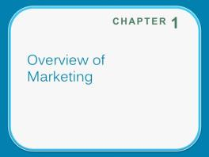
- Learning Objectives  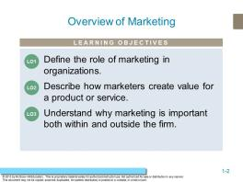 | These questions are the learning objectives guiding the chapter and will be explored in more detail in the following slides.
- Building Value Online  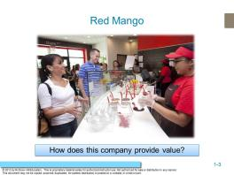 | Ask students: How many of you use these services? What do you find most valuable about these services?  Answers will include: They provide entertainment, they help me connect, and they save time.  As the text indicates, there are many ways each of these services distinguishes itself from similar services

- How is Red Mango Communicating Value?  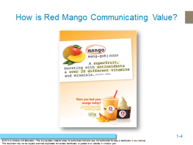 | Ask students to point the different ways that Red Mango is communication value?  Ask students if these benefits would convince them to purchase the product?
- What is Marketing?  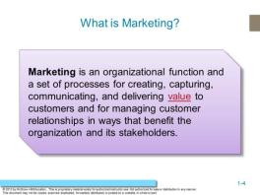 | Point out that this new definition is somewhat controversial, because many feel it includes everything within marketing.  Ask students: Do you agree? Answers might include uncertainly in the definition of value.
- What is Marketing?  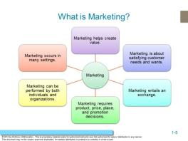 | Ask students about problems they have for which there are no products to meet their needs.  They might think about products that they could use for their homes, their computers, organizing their work, their cars.  This is how marketers generate ideas for new products – by uncovering consumer needs.

- Marketing is about Satisfying Customer Needs and Wants   | Students might mention groups based on age or gender and maybe lifestyle characteristics.  Pepsi is showcasing taste as a benefit in this ad. Other benefits that Pepsi might advertise might include low calories.
- Marketing Entails an Exchange  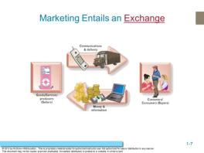 | Each party to the exchange gives up something of value:  The customer usually gives up money; however, sometimes they also give up time and information.  The firm gives up the good or service. The goal is for the exchange in the end is mutually beneficial.
- Marketing Requires Product, Price, Place and Promotion Decisions  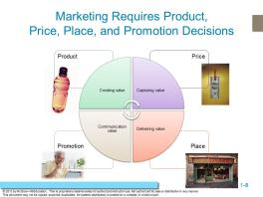 | This is an overview of the 4P’s which will be discussed in greater depth.  Ask students to choose a product they see in the classroom – VitaminWater, Coke, Aquafina – and ask them to describe the 4P’s for this product.

- Product: Creating Value  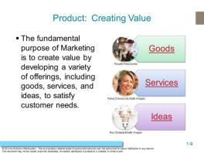 | Students often can relate to goods and services, but the marketing of ideas is a new concept to them. Use the example of drunk driving prevention;  Ask Students: How is that idea marketed?  Organizations such as Mothers Against Drunk Driving or Students Against Drunk Driving often receive support from brewers and distillers in promoting responsible drinking and safe driving.  Ask Students: What is the exchange these groups are asking consumers to enter?  Answer: They want you to consume alcohol in a manner that is consistent with safety, which means sacrificing some consumption.
- Price: Capturing Value   | A good example of how price expresses value is the variations in price associated with air travel.  The prices can vary based on demand for the flight, timing, and destinations.  Pricing strategies will be discussed in later chapters, but you may also wish at this point to introduce the notion of market pricing versus cost pricing.

- Place: Delivering the Value Proposition  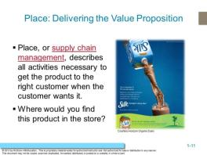 | Place delivers the product to the customers. Students may overlook the importance of this component of the marketing mix because it is not as readily visible from the consumer perspective. To get this point across, suggest a few products and then trace the path those products likely take from manufacturer to retailer to consumer.  Silk would be found in the dairy aisle, next to the milk. Milk is often a staple product that customers buy often. By placing Silk next to milk, Silk is gaining more exposure with customers.
- Superior Service AT&T   | The many wireless service companies have different reputations for service.  Ask students to share examples of great service and poor service and how that affected their perceptions of value. No doubt they will have many examples.  Probe to find out if there are certain qualities of the good service and bad service providers and make a list on the board.
- Luxury Hotels  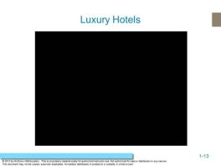 | Features the luxury hotel of St. Regent’s New York. Marketing high end travel. Focuses on selling an experience in the service industry.  Note: Please make sure that the video file is located in the same folder as the PowerPoint slides.

- Promotion: Communicating Value  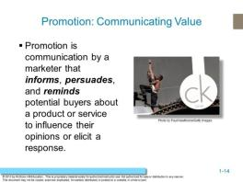 | Calvin Klein’s provocative advertising has helped create an image that is filled with youth, style, and sex appeal.
- What Element of Marketing is This?  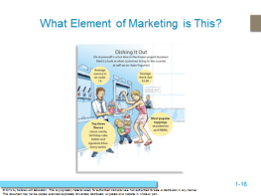 | Ask students what element of marketing is represented in this picture?  Students should recognize that this represents “Place: Delivering the Value Proposition. “ This ad focuses on a type of distribution outlet: self-serve frozen-yogurt. .
- Marketing Can be Performed by Individuals and Organizations  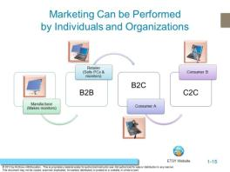 | This exhibit illustrates how the same product, a desktop computer, can be sold from firm to firm, from firm to consumer, and then be used consumer to consumer to sell C2C.  Ask students whether they’ve bought from other consumers online. Many options are available to buy C2C online, especially with the development of online cooperatives like etsy.com. Follow the web link to visit this site.

- Marketing Impacts Stakeholders  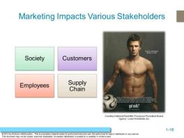 | Marketers affect many stakeholders. Customers represent one stakeholder group but others include all those in the supply chain, employees, and society at large.  Supply chain partners include manufacturers, agents, wholesalers, retailers, and so on. Companies market to employees with employment marketing, also known as internal marketing, to recruit and retain the best employees.
- Marketing Helps Create Value  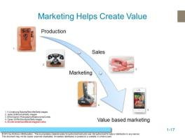 | Marketing has been through several eras. This exhibit graphically represents the changes over time from an emphasis on production to one based on value-based marketing.  The production-oriented era took place around the turn of the 20th century, when most firms believed a good product would sell itself.  In the sales-oriented era, production and distribution techniques improved and supply outpaced demand. Firms found an answer to overproduction by focusing on sales.  In the market-oriented era, the focus was on what customers wanted.  Now, we are in the value-based era, which maintains the market orientation but also includes a focus on giving greater value than the competition.  Value reflects the relationship of benefits to costs. Value-based marketing means implementing a marketing strategy according to what customers value.

- Value-Based Marketing  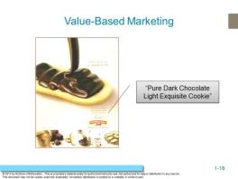 | Ask students how this campaign for Pepperidge Farm Cookies is about value. It does this by describing their ingredients in very luxurious terms…very impressive for a supermarket cookie that is not highly priced.
- Check Yourself  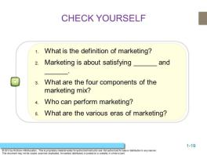 | - Marketing is an organizational function and a set of processes for creating, communicating, and delivering value to customers and for managing customer relationships in ways that benefit the organization and its stakeholders.  - Needs and wants  - Product, price, place, and promotion  - Individuals and organizations  - Production, sales, market, and value-based
- Value Based Marketing   | The Adding Value box emphasizes how value depends upon what’s important to customers.  Levi Strauss offer jeans that are affordable and stylish.

- Companies that Put the Customer First  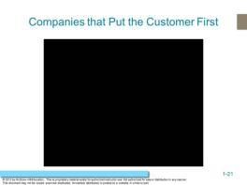 | Features the Ritz Carlton. This clip focuses on creating customer service with augmented experiences offered to the consumer.  Note: Please make sure that the video file is located in the same folder as the PowerPoint slides.
- How Do Firms Become Value Driven?  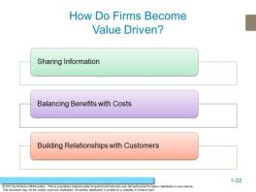 | Firms become value driven by focusing on three activities: sharing information, balancing benefits with costs, and building relationships with customers.
- Connecting With Customers  Using Social & Mobile Marketing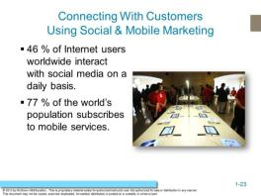 | Ask students why it is important share information using social and mobile tools?

- Target is Value Driven   | Target is a retailer which promotes value.  This web link is for a YouTube video (always check before class - these URLs can change).  This is one of Targets “Good Buy” advertisement It is interesting to ask students why this is a good advertisement  Answer: It has a strong use of music, color and movement.
- Check Yourself  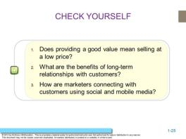 | - Value-based marketing isn’t just about low price; it is also about creating strong products and services.  - A relational orientation is based on the philosophy that buyers and sellers should develop a long-term relationship for the benefit of both parties.  - Marketers are steadily embracing new technologies, such as social and mobile media, to allow them to connect better with their customers and thereby serve their needs more effectively.
- Marketing and Society Focusing on many factors  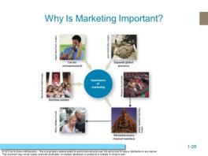 | Marketing has shifted its focus dramatically; it also has evolved into a major business function that crosses all areas of a firm or organization.

- Marketing Is Pervasive across  Marketing Channel Members  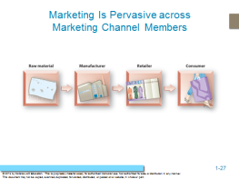 | Effectively managing supply chain relationships often has a marked impact on a firm’s ability to satisfy the consumer, which results in increased profitability for all parties.
- Marketing and Society Focusing on many factors  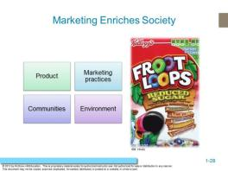 | Kellogg’s asserts:  Our values: we act with integrity and show respect.  Our foods: we produce a range of foods to meet your tastes and health needs.  Our marketing practices: long-standing commitment to responsible marketing.  In our communities: great things can happen when a company is an active corporate citizen.  Our environment: we’re helping to preserve and protect our natural resources.
- Marketing Enriches Society  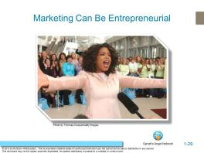 | Oprah is very entrepreneurial and an excellent marketer.  Her organizations also benefit society under the umbrella of the Oprah Winfrey Foundation.  This web link brings you to her webpage for Oprah’s Angel Network.

- Check Yourself  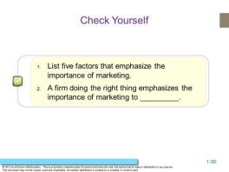 | - Expands global presence, pervasive across organization, pervasive across supply chain, makes life easier, enriches society, can be entrepreneurial.  - To do the right thing, the firm will emphasize society. This is a good time to introduce the debate of whether it is best to do right by society or right by stakeholders.

ANSWERS TO END OF CHAPTER LEARNING AIDS

Marketing Applications

1. Do you know the difference between needs and wants? When companies that sell frozen desserts develop their marketing strategy, do they concentrate on satisfying their customers’ needs or wants? What about a utility company, such as the local power company? A humanitarian agency, such as Doctors without Borders?

Needs are essential items that individuals cannot live without. These include necessities like shelter, health care, basic food and basic transportation. Wants are products that customers would like to have and view as improving their quality of life, like name brand clothing, computers, and luxury vehicles.

This question is intended to make students think about the difference between customer needs and wants, as well as how companies might address one or both. It also challenges students to explore whether different types of companies address the needs and wants of consumers differently. Companies that sell frozen desserts are probably concentrating on satisfying customers’ wants, as their products are considered “treats.” Firms also must respond to competitors’ offerings. An electric utility company might have a strong imperative to satisfy customers’ needs for reliable electricity but not focus as much on customer wants because it faces little market competition. Student responses should reflect an awareness of considering both consumers wants and needs. Humanitarian agencies, like Doctors without Borders, are satisfying customers’ needs, especially their basic needs for health care and medicine.

2. People can apply marketing principles to finding a job. If the person looking for a job is the product, describe the other three Ps.

Students should define the remaining Ps in the marketing mix and better define the product P. In addition, answers should consider how a person seeking employment can offer value to a potential employer and how employers might add value to prospective employees. Responses should answer the following questions.

What employer needs and wants can the applicant offer to fulfill (product)?

What will it cost the potential employer to higher the applicant (price)?

How will the employer promote the job to the pool of possible applicants (promotion)?

Where and when will the job be available (place)?

3. One of your friends was recently watching TV and saw an advertisement that she liked. She said, “Wow that was great marketing!” Was the ad in fact marketing?

Students frequently associate advertising with marketing, but fail to recognize that advertising is just one part of all the functions encompassed by marketing. Student responses should acknowledge that marketing is made up of product, price, place, and promotion decisions and advertising is one of the promotional tools available to marketers.

4. Mercedes-Benz manufactures the Smart Car, which sells for around $16,000, and the SL 65 AMG 2-door Roadster for over $100,000. Is Mercedes providing the target markets for these cars with a good value?

Mercedes-Benz is providing value for its customers by offering different products to different target markets. Value is created when the benefits of owning a product exceed the costs of the product. For some customers, a $16,000 automobile might be exactly the product that they need. Customers of this car might prefer the small size and great gas mileage for city driving. For other customers, the benefits of the SL 65 AMG 2-door Roadster, like its style and prestige, might outweigh the hefty price tag.

5. Assume you have been hired into the marketing department of a major consumer products manufacturer, such as Nike. You are having lunch with some new colleagues in other departments—finance, manufacturing, and logistics. They are arguing that the company could save millions of dollars if it just got rid of the marketing department. Develop an argument that would persuade them otherwise.

This scenario forces students to think about the purpose and value of marketing in an organizational context and allows for a variety of justifications. For example, a student could use an internal or external perspective and argue that finance, manufacturing, and logistics tend to worry less about the customer and more about internal processes, whereas the marketing and sales functions constantly focus outward on the customers the company serves. Using this argument, the student might question whether other departments are willing or prepared to take on customer relations and develop an understanding of how and why customers buy the company’s product or service. Another argument might simply demand how customers will even know about the company’s products if the marketing department doesn’t broadcast their features, benefits, and value outward.

6. Why do marketers like P&G find it important to embrace societal needs and ethical business practices? Provide an example of a societal need or ethical business practice that P&G is addressing.
This question centers on the role of social and ethical issues in a marketing context. Students might mention efforts such as keeping the environment clean and offering fair wages to workers. For example, Proctor and Gamble developed a Values and Policies statement so all employees and shareholders will know exactly what P&G stands for. Some of these business practices include: compliance with fair labor practices, a commitment to the environment, and a commitment to fair and accurate bookkeeping. Principles like this assure customers that P&G is a good company to work with.

Quiz Yourself
1. The “Got Milk” advertising campaign was designed to help market a(n):

a. individual.
b. firm.
c. industry.
d. organization.

The “Got Milk” advertising campaign is designed to help the entire dairy industry. This ad focuses on the dairy industry rather than a specific product or brand.

2. Henry Ford's statement, "Customers can have any color they want so long as it's black," typified the ____________ era of marketing.
a. production
b. sales
c. marketing
d. value-based marketing
Henry Ford’s statement is an example of the production era of marketing where companies worked to achieve economies of scale rather than make products more targeted to customers’ specific needs and wants.

Net Savvy

- Visit Apple (www.apple.com). What value does Apple provide customers? What are the advantages to using Apple to buy music or to rent/buy videos?

Most students should be familiar with Apple products and services. Students might suggest that Apple provides value because of the convenience and ease of use of its products. Apple may also provide value because of the compatibility of all of its products and services. Some of the advantages of using Apple to buy music or to rent/buy videos are the ease of use, broad selection, and newness of the music and movies.

- Go to Facebook.com/facebook/info and newsroom.fb.com. What is Facebook’s mission? How could a marketer use Facebook and what other social media tools could they use? What are the drawbacks a marketer might face when using Facebook?

Mission: Facebook's mission is to give people the power to share and make the world more open and connected.

For the aggressive guerilla marketer, Facebook offers a variety of viral channels to get the word out and creatively reach target audiences. For marketers with a budget, Facebook offers both integrated and self-serve solutions to reach broader slices of the Facebook audience. For marketers who can harness technical resources, the Facebook Platform offers the most powerful way to create engaging connections with your target audience on Facebook.

Chapter Case Study: The Yogurt Wars: Pinkberry vs. Red Mango

- What are the similarities and differences in the ways Red Mango and Pinkberry create value for their customers?

Pinkberry and Red Mango have similar strategies. Pinkberry and Red Mango both create value by offering customers a healthy alternative to ice cream. Both companies have whimsical and modern store designs. Pinkberry has a unique combination of creativity, taste and healthfulness. Pinkberry also uses endorsements from celebrities. Red Mango also adds value with an increased product assortment including fresh fruit parfaits, smoothies, teas, and chocolates.

- What is Pinkberry doing to add value for international customers?

Pinkberry is adding value for international customers by developing yogurt flavors and toppings that reflect local preferences, like dates and pistachios for Middle Eastern markets and green-tea flavored yogurt for Asian markets.

- Visit the websites for Pinkberry and Cold Stone Creamery. What differences do you notice in the colors and pictures used on the sites? Are there differences in how the products are described? How do these differences communicate the value messages being communicated by the different companies?

The Pinkberry website uses lighter colors and shows images of its products on the home page. In addition, the Pinkberry website plays music when the home page comes up. The Pinkberry products are described using words like “fresh,” “organic,” and “natural.” The Pinkberry website is very modern and light.

The Cold Stone Creamery website features the company’s signature colors of red and black. The home page is much more informative than the Pinkberry home page. Cold Stone highlights its use of the “finest” ingredients in its products.

Pinkberry’s website is trying to communicate its more natural and healthful offerings, while Cod Stone is communicating the indulgence and uniqueness of its products.

- Do you like self-serve options such as the ones Red Mango is offering in some stores? Why or why not?

Yogurt and ice cream stores offer self-service options allowing customers to make their own ice cream or yogurt creations and choose their own toppings. A cashier will weigh the customer’s final product and charge by the ounce. This option allows customers to interact more with the product and also saves the company on overhead expenses like labor.

Ask students if they prefer this option or if they would rather have someone make their treat for them. Do they end up buying more or less when they use the self-service option?

ADDITIONAL TEACHING TIPS

In this chapter, the goal is to provide an overview of marketing and encourage students to think about the specific aspects of the marketing mix.

Place is one of the most difficult concepts for students because it is largely invisible to them as consumers. They touch hard goods, experience services, view and hear promotions, and pay for what they buy, but it can seem that products almost appear magically. One recent trend among environmentally-conscious consumers is to seek out products produced within a 100-mile radius of their home towns. Buying these products reduces costs and detrimental environmental effects by reducing emissions associated with transportation and storage. Students should visit local grocery markets, identify goods, and investigate how far the products traveled (and by what means) to reach the store’s shelves. From this experience, a rich discussion of both distribution decisions and marketing’s impact on society can evolve.

To make the eras of marketing clear to students, divide the class into groups with each group assigned to a specific era. Ask the students to identify a business that adheres to their assigned era in terms of its business philosophy and approach. They should present the business to the class with evidence of the business’s philosophy. Each brief presentation should include an assessment of whether the orientation is appropriate to the business given its competitive environment, target audience, and positioning strategy and if not, what orientation would be best.

Remember to review the Newsletter for Instructors and its accompanied PowerPoint presentation, which integrates examples and discussion from the newsletter. Each newsletter contains over ten article abstracts on hot topics, plus a selection of current commercials and videos for you to use with your class. The newsletter also includes a guide that explains where the articles, commercials, and videos best fit in your Marketing course.

Justin Smith, "The Facebook Marketing Bible: 24 Ways to Market Your Brand, Company, Product, or Service Inside Facebook," Inside Network, Inc., December 9th, 2007

